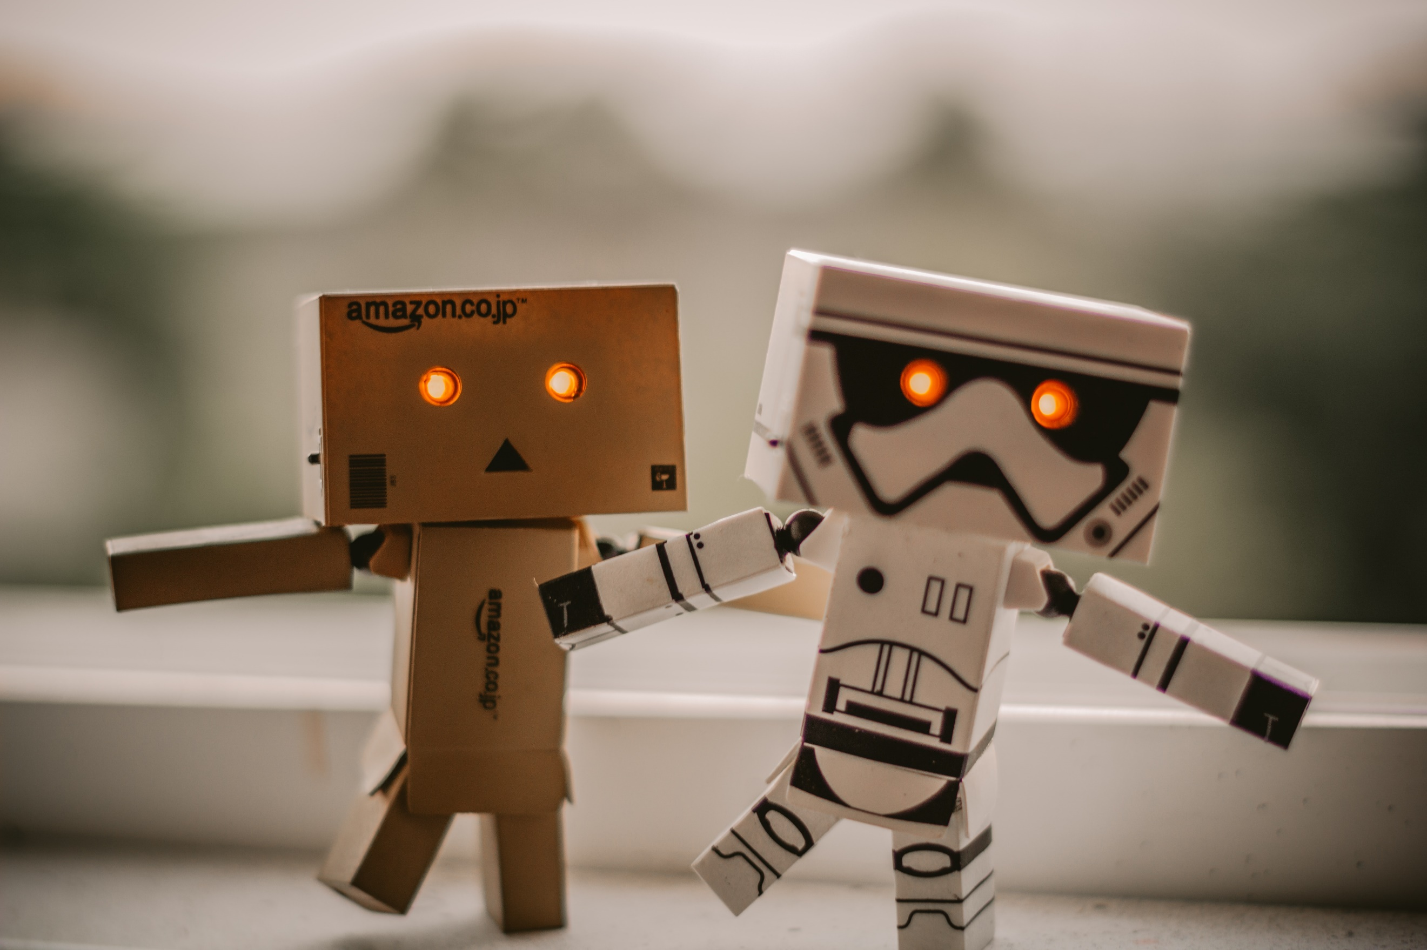  AI IN robotics  Coursework 1 | Group Members: Angel Magala  Mehtaab Andoo  Sebabatso Maloi  Module Tutor: Nivede Issur  Submission Date: 02 November 2025

Table of Contents
Table of Figures 2
Introduction 3
Mission and Tasks 3
Required Skills 0
Hardware Components 0
Software Architecture 3
Dataset and Model Plan 5
Error Analysis 7
Risk and Safety 10
Budget / BOM 14
Conclusion 14
Reference List 15
Appendix 22
Contribution Table 22

Table of Figures
Figure 1 Fallback Decision flow 8
Figure 3- Module communication flowchart 3
Figure 4- Robot Interaction 4
Figure 5: Learning rate graph 6
Figure 6: Second learning rate graph 6
Figure 7: Head training 7
Figure 8 Entire Modelling training 8
Figure 9 Classification Report 8
Figure 10 Confusion matrix 9
Figure 11 Prediction from UI 10
Figure 12- Fallback Decision Flow 11

Introduction
The intelligent, ceiling-mounted office assistant Aerius autonomously identifies, organizes, and manages office supplies. Its name, inspired by ‘air’ and ‘aerial’ mobility, reflects its sleek design and ceiling-mounted operation. This report outlines Aerius’s design, required skills, hardware and software architecture, dataset and implementation plan, safety measures, and budget considerations.

Mission and Tasks
Aerius maintains a clean, organized, and efficient workspace by locating, classifying, and storing items, while coordinating with other maintenance robots. It moves along a ceiling-mounted rail system, saving space and energy, and can be activated automatically or by command for tasks like inventory management, organization, and light cleaning. Its telescopic arm extends only as needed, using precise X, Y, Z positioning to handle objects safely.
Detailed Task List
1. Scanning and Mapping
- Uses LiDAR and cameras to scan the office environment.
- Creates and updates 3D maps of floors, desks, shelves, and drawers.
- Detects dirty or cluttered areas for cleaning coordination.
2. Item Detection
- Recognizes common office supplies via AI and computer vision.
- Differentiates between misplaced and categorized items.
- Detects dust or surface mess using floor sensors.
3. Priority Setting & Decision Making
- Evaluates workstation conditions to determine tasks (cleaning, sorting, tidying).
- Sets task priorities based on user preferences, item type, and urgency.
- Interfaces with office management system for planned maintenance.
4. Planning & Navigation
- Moves via ceiling-mounted rails with X, Y, Z axes for precise positioning.
- Stepper motors and sensors ensure safe, collision-free travel.
- Calculates shortest, safe routes and coordinates with cleaning robots.
5. Object Manipulation
- Equipped with multi-fingered, soft-grip end effector.
- Adjusts grip strength and angle according to object fragility and material.
6. Placement & Organization
- Automatically arranges desks, meeting tables, and common spaces.
- Sorts items into smart drawers or storage areas based on accessibility and usage.
7. Inventory & Monitoring
- Tracks identified objects in a digital catalogue.
- Assists in locating lost items accurately.
8. User Control & Management
- Responds to voice commands, gestures, or mobile app inputs.
- Provides feedback on task completion and inventory status.
- Supports custom scheduling for routine tasks.
9. Tidying & Cleaning
- Uses micro-vacuum or mini-cleaner to remove dust and debris.
- Floor sensors communicate with Aerius for cleaning schedules.
10. Docking & Self-Maintenance
- Retracts to ceiling bay for wireless charging and self-cleaning.
- Runs diagnostics on sensors and grippers
- Updates firmware automatically via cloud.
11. Adaptive Learning
- Learns user behavior and workspace trends over time.
- Recognizes frequently used items to improve accessibility.
Below is a flowchart representation of the basic functions of Aerius:
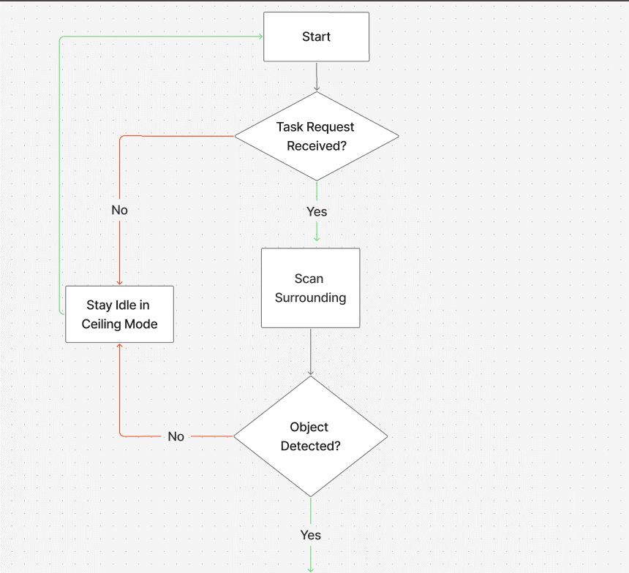
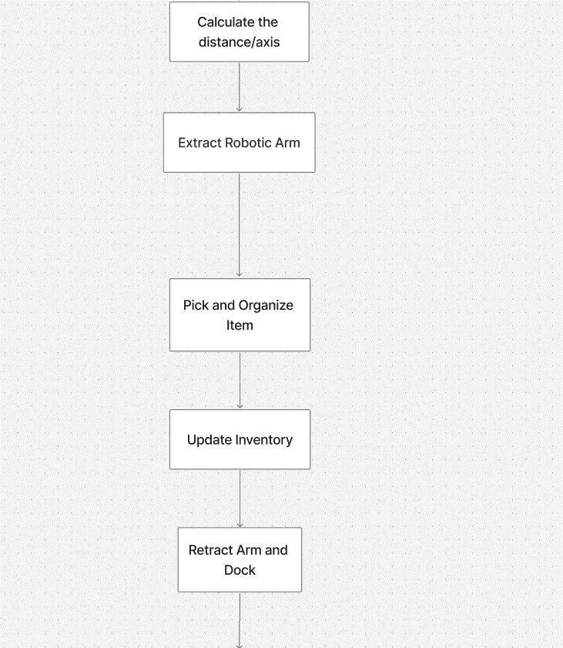


Figure 1 Fallback Decision flow

Required Skills
In the table below, Aerius’s required skills to execute the tasks above, description of the input and output criteria, along with the success criteria are explained.
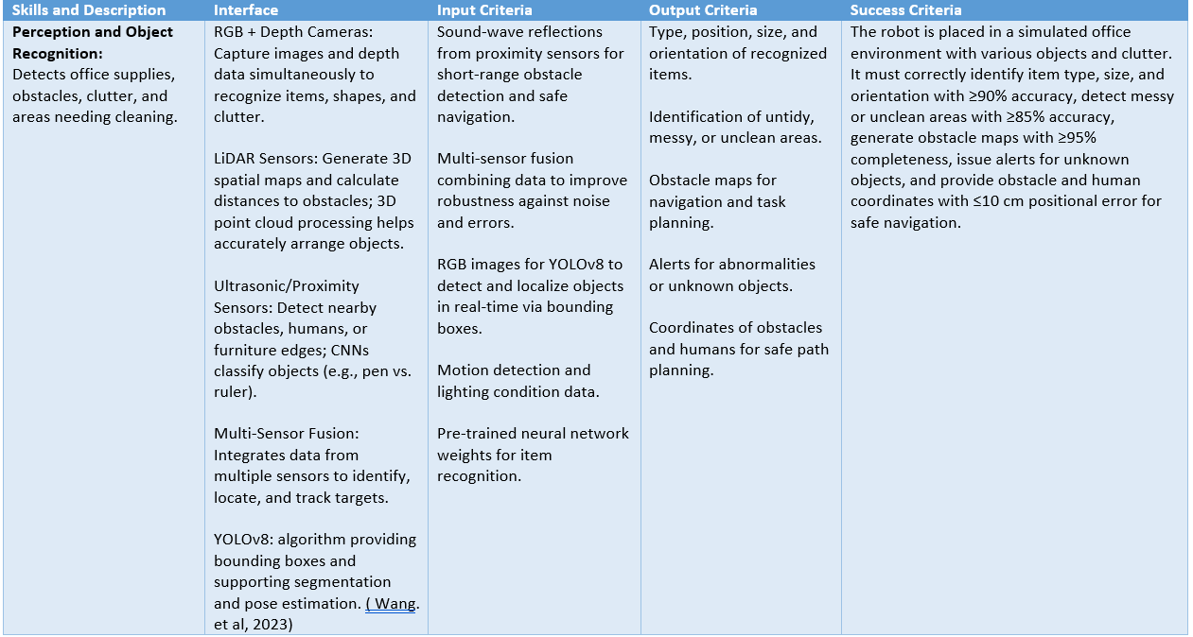
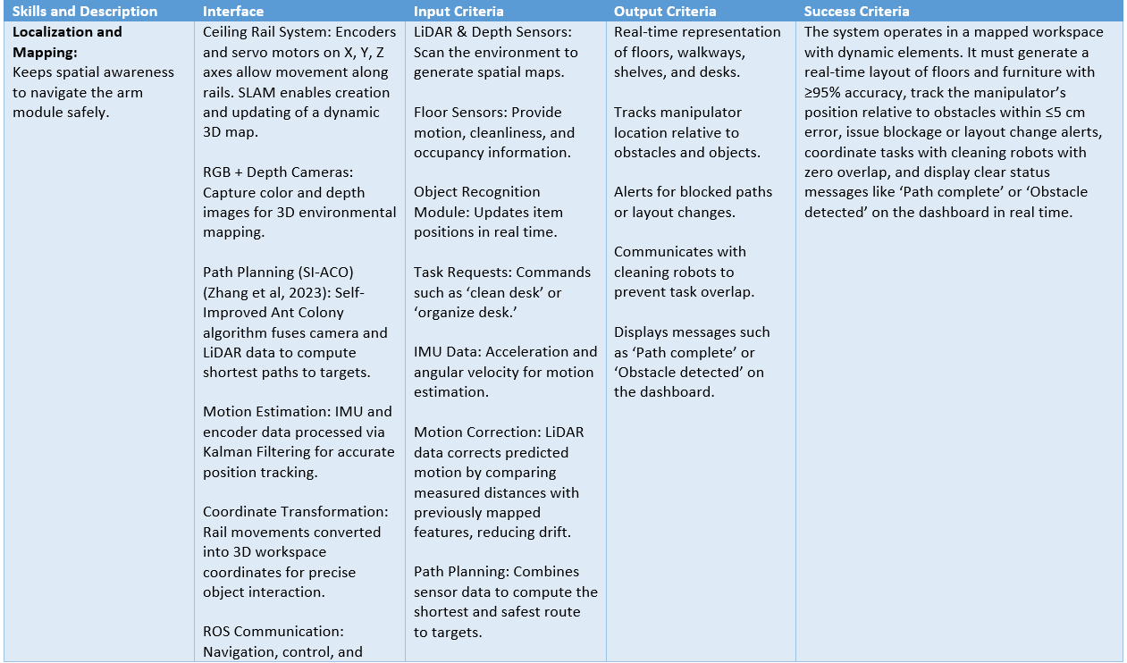
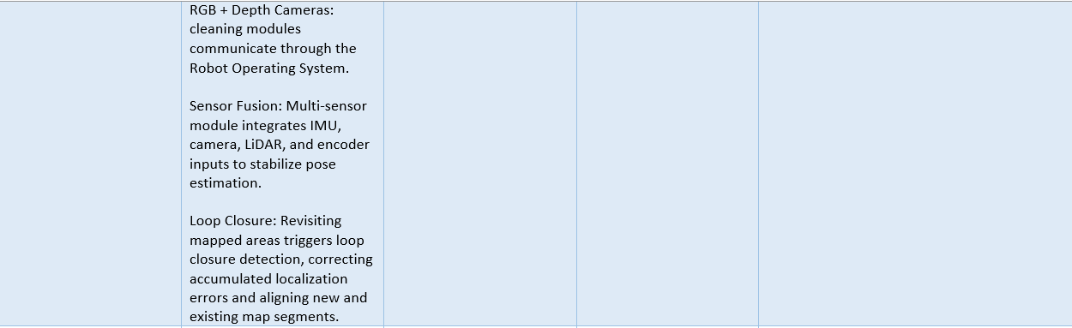
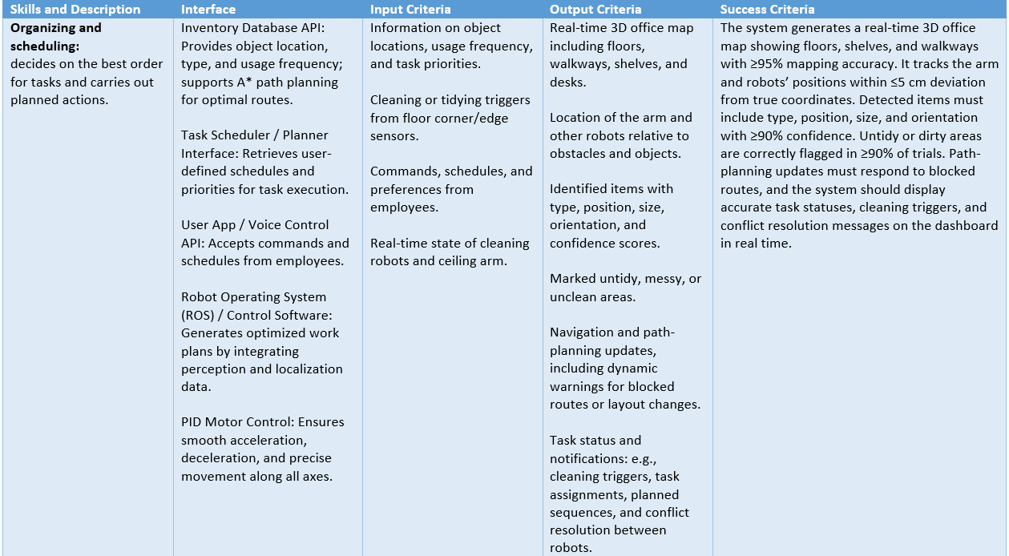
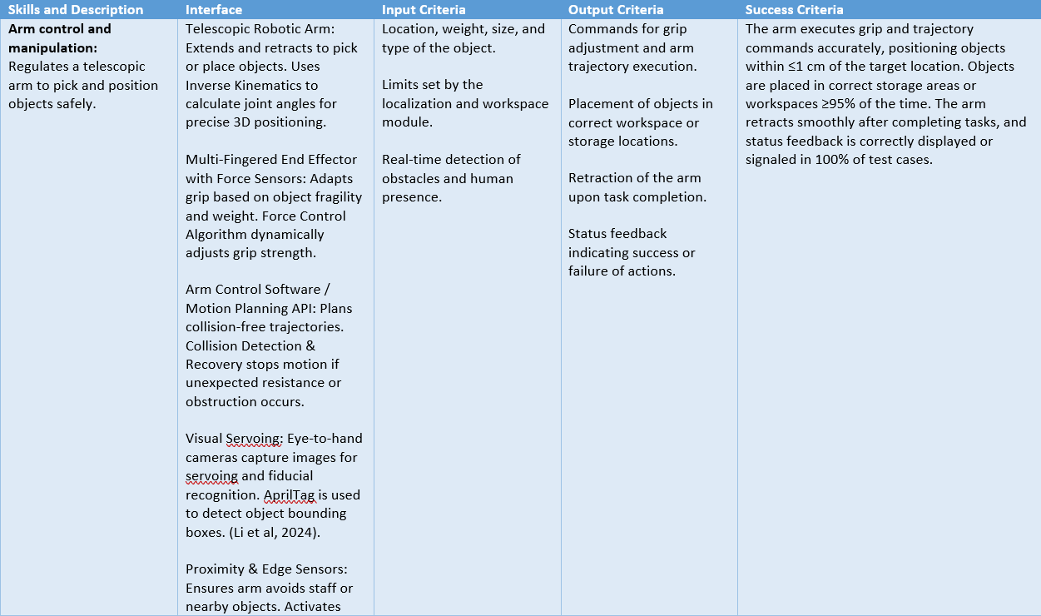

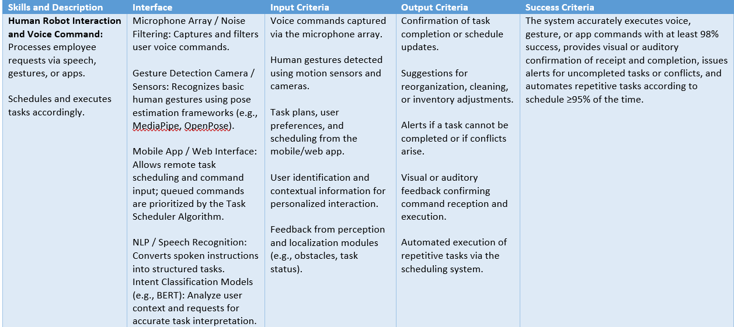

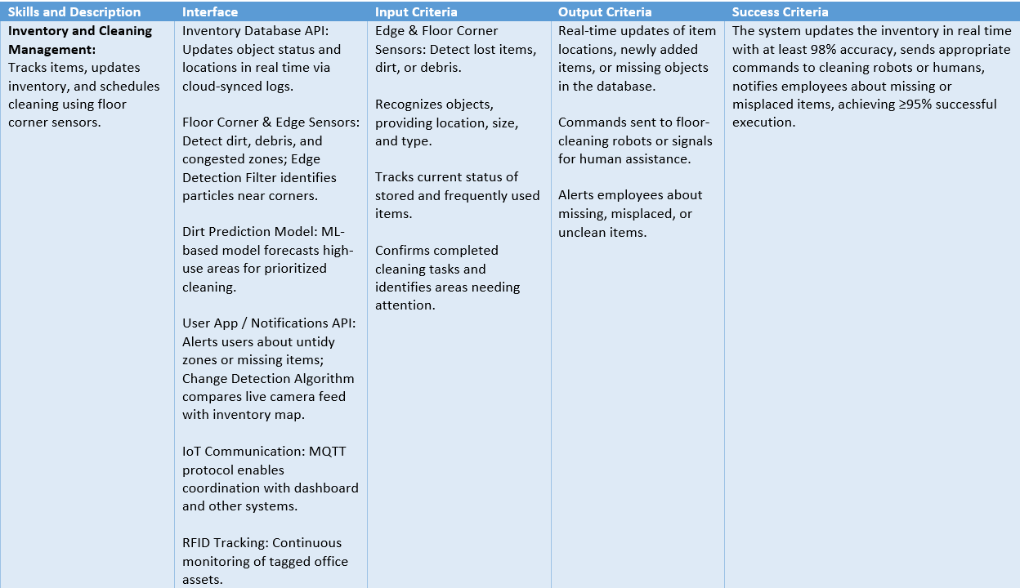

Hardware Components
Sensors
- RGB Camera
Selected: Intel RealSense D415 - It combines RGB and depth sensing, offers an 87° field of view, a depth ranges up to 6 m, USB connectivity, and native ROS2 & OpenCV support, making it suitable for precise measurements in various lighting conditions (Intel, 2025).
Alternative: LUCID Helios2 Wide - Provides a wider field of view (108° × 78°) and depth sensing up to 8.3 m, suitable for ceiling-mounted applications, but lacks an integrated RGB module. (LUCID, 2025).
- Depth Camera / RGB-D
Selected: OAK-D (Luxonis) - Compact and ideal for robotic integration, it combines stereo depth with onboard AI inference, providing good depth accuracy from 70 cm to 12 m with less than 2% error below 4 m, while reducing processing load (Luxonis, 2025).
Alternative: Intel RealSense D435 - Suitable for low-light conditions and budget-friendly, with a strong external compute requirement, but has a narrower field of view (65° × 40° in HD mode) (Intel, 2025).
- 2D LiDAR
Selected: Slamtec RPLIDAR S2 - Offers a 30 m measuring range, 32 k measurements/sec sampling, 0.1125° angular resolution, and is dust- and waterproof, making it highly accurate and durable (SLAMTEC, 2025).
Alternative: RPLIDAR A3 - Suitable for indoor mapping and dynamic obstacle detection, with precise and fast scanning at a more budget-friendly price (SLAMTEC, 2025).
- IMU (Inertial Measurement Unit)
Selected: Bosch BNO055 - Integrates onboard sensor fusion for precise orientation and motion tracking, reducing software complexity (Bosch Sensortec, 2025).
Alternative: MPU-9250 - Offers a 9-axis sensor at lower cost, but requires additional software to perform sensor fusion (InvenSense, 2025).
- AprilTags / Fiducial Markers
Selected: AprilTag v2 - Provides highly accurate localization and mapping for robotics with minimal computational load (Luxonis, 2025).
Alternative: ArUco Markers - Commonly used in computer vision and easily integrated via OpenCV, but slightly less precise (Luxonis, 2025).
- Safety Proximity Sensors
Selected: HC-SR04 Ultrasonic Sensor - Cost-effective and reliable for short-range distance measurements, suitable for preventing collisions in close-quarters tasks (SparkFun, 2023).
Alternative: VL53L1X Time-of-Flight (ToF) Sensor - Offers faster sampling and higher accuracy, enhancing obstacle detection in dynamic environments (Microelectronics STM, 2022).
Manipulations
- Telescopic Robotic Arm
Selected: UFactory xArm 6 DoF - Provides precise 6-DOF movement for confined spaces, integrates easily with ROS, and has sufficient payload capacity with high-performance brushless servo motors (UFactory, 2025).
Alternative: Dobot Magician - A more affordable 4-DOF robotic arm suitable for educational purposes, but limited in precision and workspace flexibility compared to the xArm (Dobot, 2025).
Note: To cover a larger working range, we can add the Electric Linear Actuator.
- Arm Linear Actuator
Selected: Electric Linear Actuator - Allows precise and controlled extension/retraction of the telescopic arm when integrated with ROS-based motion planning (Firgelli Automations, 2023).
Alternative: Pneumatic Cylinder - Offers faster movement and higher load capacity but requires compressors and more maintenance (SMC Corporation, 2023).
- Soft-Grip End Effector
Selected: Robotiq 2F-85 Adaptive Gripper - Versatile for handling various objects with shape adaptation without causing damage (Robotiq, 2025).
Alternative: OnRobot RG2 - Compact design suitable for lightweight objects with adequate payload capacity (OnRobot, 2025).
- Ceiling Rail Movement Actuators
Selected: Stepper motor linear gantry system - Provides precise and repeatable positioning along ceiling rails, ideal for accurate ceiling-mounted motion (Oriental Motor, 2025).
Alternative: Servo-driven linear actuators - Offer high torque and speed but require more complex control systems and are costlier (SMC, 2025).
- Rail System Controller / Motion Controller
Selected: Stepper motor driver stack - Trinamic TMC-series drivers on a dedicated controller provide silent, smooth, and precise ceiling gantry motion with microstepping and stall-detection, balancing performance and cost (Trinamic Motion Control, 2023).
Alternative: Servo motor drive - Delta/Kollmorgen closed-loop drives deliver higher speed and torque for heavier payloads but require more complex tuning and safety measures (Siemens, 2023).
- Ceiling Mount Frame / Docking Bay
Selected: Custom aluminum frame (CNC-milled) - provides a robust, vibration-resistant structure for secure ceiling-mounted operation (Bosch Rexroth, 2023).
Alternative: Modular 3D-printed mount (PLA/ABS) - allows rapid prototyping and cost-effective customization but may lack the rigidity of metal frames (Ultimaker, 2023).
Communication

- Microphone Array
Selected: ReSpeaker 6-Mic Array - provides reliable voice command detection with beamforming and noise suppression for accurate recognition (ReSpeaker, 2023).
Alternative: Logitech Mic Array - more affordable and sensitive but offers lower directional accuracy (Logitech, 2023).
- Visual Feedback Display (Dock / Robot)
Selected: 2.4" color TFT display + RGB LED ring - displays text, icons, and progress bars with immediate, clear status feedback when combined with an LED ring (Adafruit, 2023).
Alternative: Single-color LED matrix - more affordable and visible, but less flexible for conveying complex status indicators (Waveshare, 2023).
Cleaning
- Dust Filter / HEPA Module (for micro-vacuum)
Selected: Replaceable HEPA13 cartridge + washable prefilter - ensures indoor air quality by efficiently capturing fine particles and allowing easy replacement (Honeywell, 2023).
Alternative: Electrostatic precipitator + washable filter - can reduce airflow resistance and capture particles but requires more maintenance and is sensitive to moisture (Dyson, 2023).
- Sensor Cleaning Mechanism (Air-jet / Wiper)
Selected: Small solenoid-controlled air-jet + silicone wiper blade - provides an affordable and efficient way to remove loose dust from cameras and lenses in the field (DustTech, 2023).
Alternative: Ultrasonic vibration dust removal / electrostatic coating - reduces mechanical wear but is more costly and complex to implement (Nano-Clean, 2023).
Safety
- Emergency Stop Switch / Safety Cutoff
Selected: Schneider Electric XB4 Series - industrial-grade emergency stop providing rapid power isolation and reliable operator safety (Schneider Electric, 2023).
Alternative: Omron A165E Series - more compact and suitable for ceiling installations, but may respond slower in some cases (Omron, 2023).
- Safety Bump / Proximity Sensors (Arm & Rail)
Selected: Multi-zone time-of-flight (ToF) proximity sensors + capacitive touch strips - provide fast, adjustable, non-contact detection and immediate stopping on contact for enhanced human safety (STMicroelectronics, 2023; Microchip, 2023).
Alternative: Mechanical bump sensors and simple IR proximity - cost-effective and easy to implement but less reliable at close range and sensitive to ambient light (SparkFun, 2023; Sharp, 2023).

Software Architecture
Aerious software follows a modular ROS 2 architecture, where sensor nodes supply raw data to perception and localization modules. These modules process the environment and provide actionable information to the planning and control nodes. Consider the diagram below showing the dataflow in Aerious’ system.
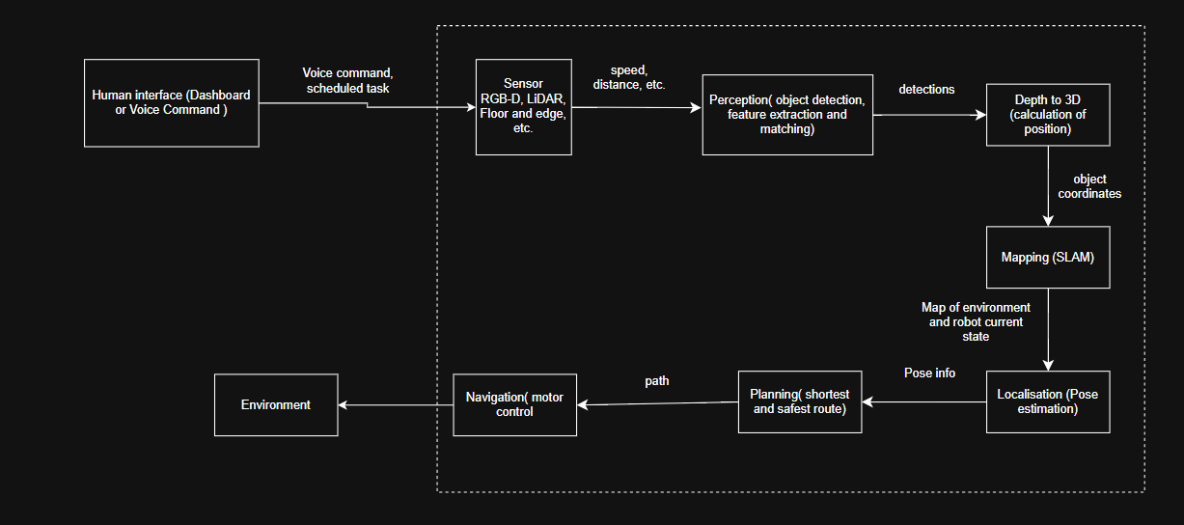
Figure 3- Module communication flowchart
ROS TOPICS AND FRAMES
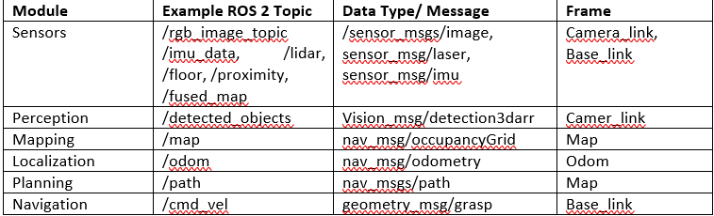
The ROS2 dataflow diagram shows the interaction between the robot’s perception, planning, and control modules. Sensor nodes publish data to topics, which the Sensor Fusion Node combines. The fused data is processed by the YOLOv8 detection node, then sent to the SI-ACO path planner to generate an optimized route. Motion Control converts this path into velocity commands, while safety nodes monitor obstacles and trigger emergency stops when necessary.
Consider this diagram below.
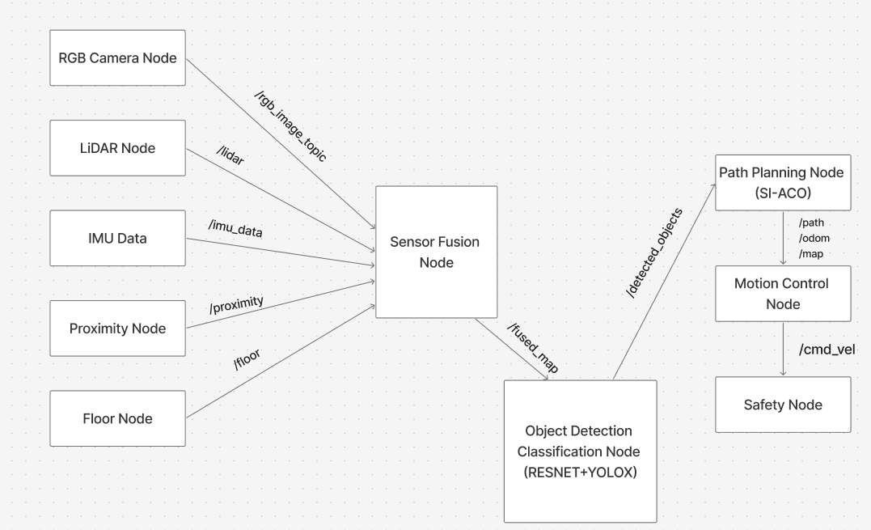
Figure 4- Robot Interaction

Dataset and Model Plan
The image classification model was created to recognize a total of 10 classes of office items: notebook, backpack, pen, file cabinet, mug, trashcan, laptop, chair, table and mouse.
An online Office-Home dataset (Venkateswara et al., 2017) of 62 office item classes was obtained for training and validating the model. The dataset was organized in 4 major folders named Clipart, Art, Product and Real World and each folder contained subfolders containing specific office items. Folders that contained office items not related to the chosen classes were removed. The dataset was organized using a python script to merge the same office items across the 4 major folders into one distinct folder. The names of the folders containing a particular office item served as a class label for that item and each class contains around 300 images. Some unclear and cropped images were removed and replaced by other photos online found online. An additional dataset was obtained from another online site (Images.cv, 2025) to test the model. These datasets were chosen because they had images pertaining to the chosen classes, they had a variety of images and a satisfactory amount of images needed for transfer learning.
Transfer learning was carried out using ResNet34, a 34-layer convolutional neural network selected for its ability to capture complex patterns and outperform shallower models like ResNet18 in accuracy (Subaar et al., 2024). Additionally, ResNet34 achieves high classification accuracy across various domains (Subaar et al., 2024) when leveraging pretrained ImageNet weights. It requires a relatively small dataset, which suited our scenario with roughly 3,000 training images, and it’s less prone to overfitting than ResNet50. Unlike ResNet50, ResNet34 demands less computational power, making it compatible with the limited resources of our devices. Overall, ResNet34 was an ideal choice for developing an office classification model, as it offers a good balance between accuracy and efficiency in resource-limited settings.
To customize ResNeT34 to the office item domain, several parameters were altered. The optimization function was changed from Adaptive Moment Estimation (Adam) to Stochastic Gradient Descent (SGD) because SGD performs better than Adam in terms of better generalization on image classification tasks (Gupta et al., 2021). During training, different learning rates were used when training the classifier head and when fine-tuning the entire model. The changes in learning rates were necessary because the final classification layer is randomly initialized each run, affecting the model’s sensitivity to the learning rate.
The loss function that was used was cross-entropy loss because it is suitable for multi-class classification. It guides models to output probabilities close to true class labels by minimizing errors between predicted and actual outcomes. Cross-entropy loss was therefore, suitable in the office item classification scenario.
To find the appropriate learning rates, a learning rate finder was used to plot loss against learning rate. The value chosen for the head of the model was chosen around the “valley” before the loss increases sharply.
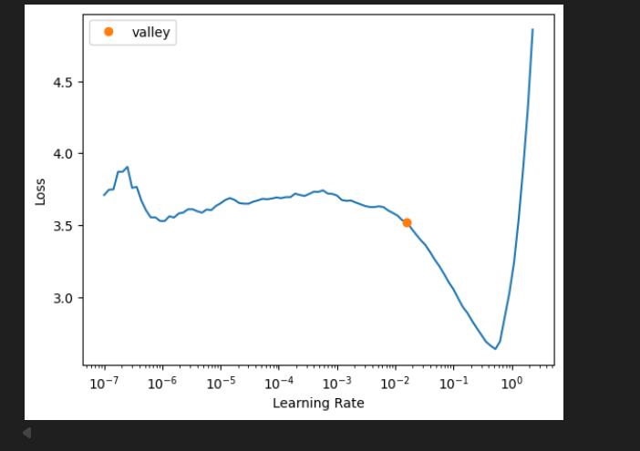
Figure 5: Learning rate graph
Based on figure 4, the learning rate of 1e-2 was used for training the head because the valley mark is around 1e-2.
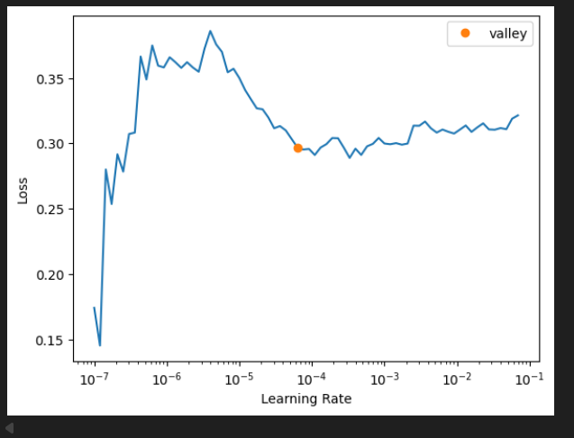
Figure 6: Second learning rate graph
In Figure 5, the loss is steady from the learning rate of 1e-5 to 1e-4, where the valley mark is. This range, 1e-5 to 1e-4, was used because that is the region where the model learns efficiently as the loss decreases gradually. Therefore, this range was chosen for fine-tuning the entire model to ensure that the pretrained weights were not disrupted.
For performance evaluation, accuracy, recall, precision, F1 score, macroF1 and confusion matrix calculated.

Error Analysis
This section of the report analyses the training results and performance of the model on a test dataset and discusses the error.
Recall was used to measure the ability of the model to correctly identify items of a given class and to ensure that the model does not miss or overlook some office items.
Precision was used to evaluate the model on how reliable it is in predicting a certain class and not confusing it for another class.
F1 Score was also used to balance precision and recall preventing bias and ensure fair evaluation.
A confusion matrix was also used to visually show classes the model correctly and incorrectly categorized to help identify where misclassification occurred.
Finally, accuracy was also used to show how well the model can correctly categorize an office item.

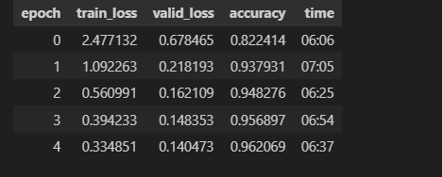
Figure 7: Head training
Figure 6 shows the results of the head training. There were no signs of overfitting during the head training phase. Overfitting occurs when the training loss decreases but the validation loss increases, meaning it performs well on the training data but poorly on the unseen validation data it decreased.
In this case, both the training loss and validation loss kept on decreasing with each epoch from 0.678 on epoch 0 to 0.140 on epoch 4 with an accuracy of 96.2%, this shows that the model is generalising effectively and learning features of the distinct classes.
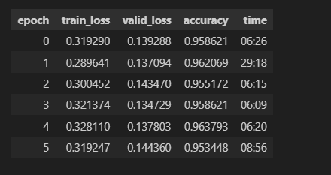
Figure 8 Entire Modelling training
Figure 7 shows results of the entire model training. There were signs of minor overfitting starting after epoch 1 with the validation loss increasing from 0.137 to 0.143 in epoch 2, but after the increase the model reaches its lowest validation loss of 0.134 in epoch 3 which showed better generalisation at that point. At epoch 5 is where the validation loss is at its highest among the epochs at 0.144, it is at this point where there is a clear sign of overfitting.

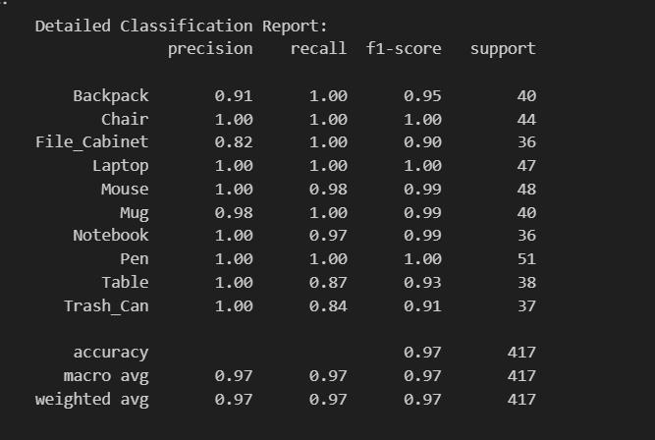
Figure 9 Classification Report
Figure 8 shows a classification report of the model. F1 score, macro-F1, accuracy, recall, precision were used to analyze the model. The range of precision across all classes is from 0.82 being file cabinet to 1 which include. File cabinet having a precision of 0.82 can be due to the similarities in features like the drawers it has with an office table/desk. For classes with a precision of 1 like chair, pen and table means that it is very unlikely for the model to confuse the classes for another class whereas for a class like file cabinet, the model can misclassify file cabinet around 20% of the time. The range of recall across classes is from 0.84 to 1, with 0.84 being trash can. This means around 16% of the time the model could not correctly identify a trash can, this could have been due to the different varieties, shape or even features of a trash can. The f1 score ranges from 0.91 to 1, with 0.91 being trash can. The range indicates that there are low false positives and low false negatives meaning there is a high probability of high correct predictions and rarely misses an instance of a class, therefore there is a balance between precision and recall. The macro F1 score is 0.97, which indicates that the model is good at identifying a particular class and rarely mistakes a class for another class.
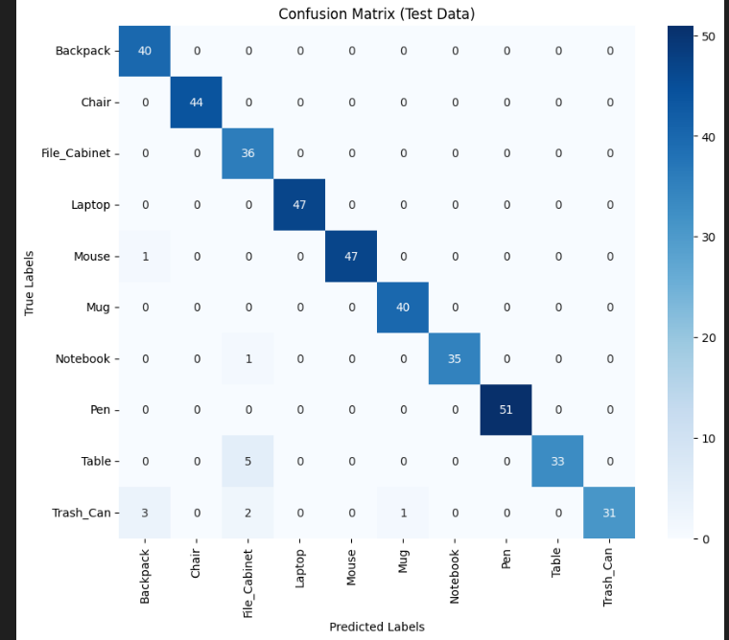
Figure 10 Confusion matrix
The confusion matrix in figure 9 shows that the model correctly predicted classes most of the time. The highest misclassification was when the model wrongly predicted 5 instances of File cabinet for table, this supports the analysis made above(figure 5) that this probably happened as office tables/desks and file cabinets share same features such as drawers. The number of instances which were wrongly predicted for each class were <=5, which suggests that the model generally performs well and makes a few misclassifications.
Despite the slight overfitting that occurred during training (figure 4), the model still performed very well on the test data(unseen data), with a 96.9% accuracy, an error rate of approximately 3.1% and a number of wrong predictions of instances of each class being <=5 . The overfitting could have led to the small error rate and wrong predictions as the model was not learning but memorizing patterns. The overfitting could have been avoided by reducing the number of epochs, increasing data augmentation or using weight decay to aid in generalisation.
Practically, our classification model generally works well for both the webcam and uploading of an image. Consider the variation below.
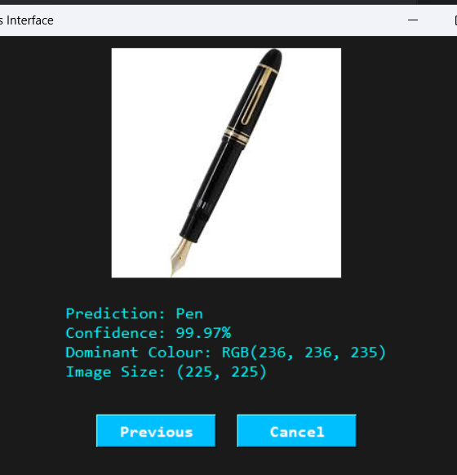 | 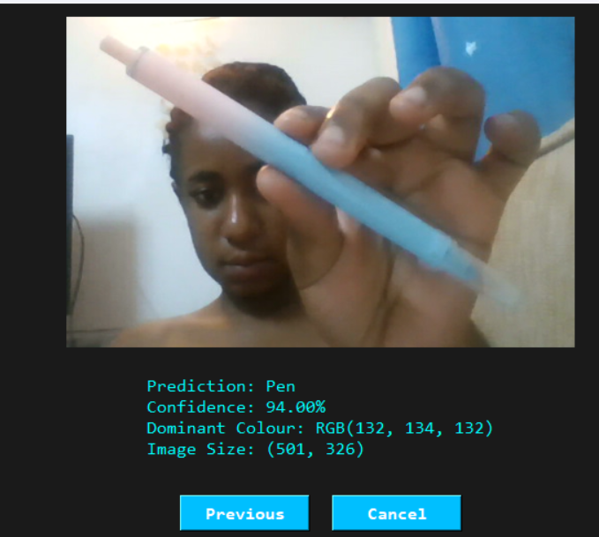
Prediction after uploading image | Prediction after capturing from the webcam
Figure 11 Prediction from UI
Here we notice a decrease in confidence between the two interfaces, whereby the webcam predicts lower than the upload. This could be due to the blurriness of the camera and low lighting. In any case, the score are still well fitted with both still performing >90%.
In the context of the Aerius robot, whose main mission is placing office items in their appropriate areas, using a model with 96.9% accuracy and few misclassifications is suitable for deployment. An error rate of approximately 3.1% could lead to certain office items being rarely placed in the wrong areas, which is not life-threatening or of high consequence. Therefore, the model will allow the robot to fulfill its tasks and mission.

Risk and Safety
Emergency Stop (E-stop)
Aerius features an emergency stop (E-stop) that instantly halts all motions when pressed or triggered automatically under abnormal conditions. This fail-safe system complies with ISO 13850 and KUKA Robotics safety guidelines (International Organisation for Standardisation, 2015; KUKA Robotics, 2021).
Speed Caps
Aerius uses software-enforced speed limits to restrict rail and arm movements in shared workspaces. Speed automatically decreases when sensors detect nearby humans. This ensures safe kinetic energy levels in line with ISO/TS 15066 and Universal Robots guidelines (International Organisation for Standardisation, 2016; Universal Robots, 2020).
Minimum Obstacle Distance
Aerius maintains a dynamic safety buffer using sensors and LiDAR to keep a minimum distance of 30–50 cm from people or objects. It slows, stops, or reroutes using its path planner when the buffer is breached. This approach aligns with ISO 10218-2 and Siemens safety guidelines to reduce collision risks (International Organisation for Standardisation, 2011; Siemens, 2022).
Fallback Mode (Detection and Localise Failure)
Aerius enters Fallback Mode when sensors fail or localisation confidence is low, halting motion and returning safely to its dock. This ensures it never operates blindly, following fail-operational design principles. The approach complies with ISO/TR 13309 and NVIDIA safety recommendations (International Organisation for Standardisation, 2018; NVIDIA, 2023).
Proximity & Force Feedback Protection
Aerius uses force and proximity sensors in its arm and soft-grip to detect unexpected resistance or human contact, stopping and retracting instantly. Vision checks ensure safety before resuming motion. This force-feedback system aligns with ISO/TS 15066 and ABB Robotics safety guidelines (International Organisation for Standardisation, 2016; ABB Robotics, 2021).
Thermal, Electrical, and System Safety
Aerius has temperature regulation, current monitoring, and overload protection for its rail and arm actuators. These systems halt operation and send diagnostics if thresholds are exceeded. Such measures ensure electrical safety and device durability, complying with NASA and IEC 60204-1 standards (NASA, 2020; International Electrotechnical Commission, 2016).
Human Presence & Occupancy Detection
Aerius uses AI-based human detection and motion sensors to halt movement near workers, resuming only once the area is clear. This ensures safe operation in shared workspaces. The system complies with ISO 13482:2014 and Boston Dynamics safety guidelines (International Organisation for Standardisation, 2014; Boston Dynamics, 2021).
Below is a safety/fallback decision flow:
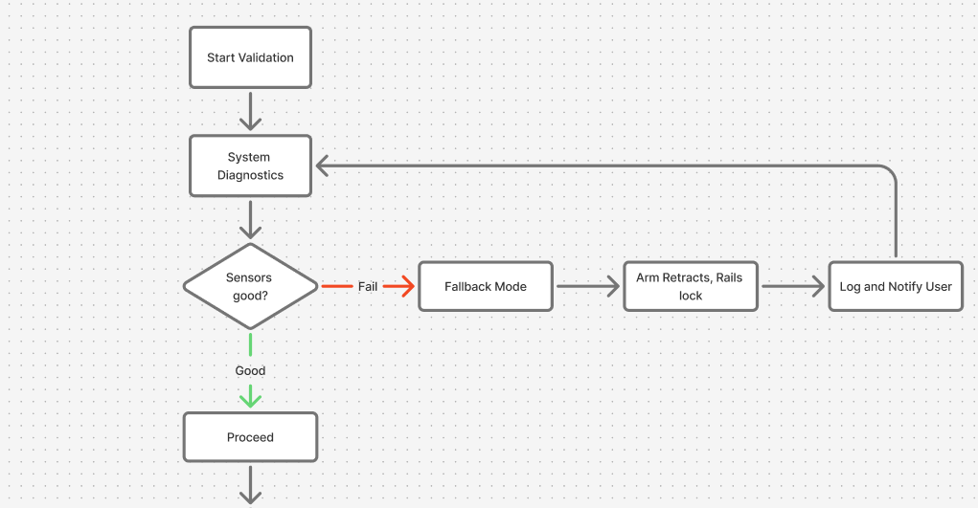
Figure 12- Fallback Decision Flow
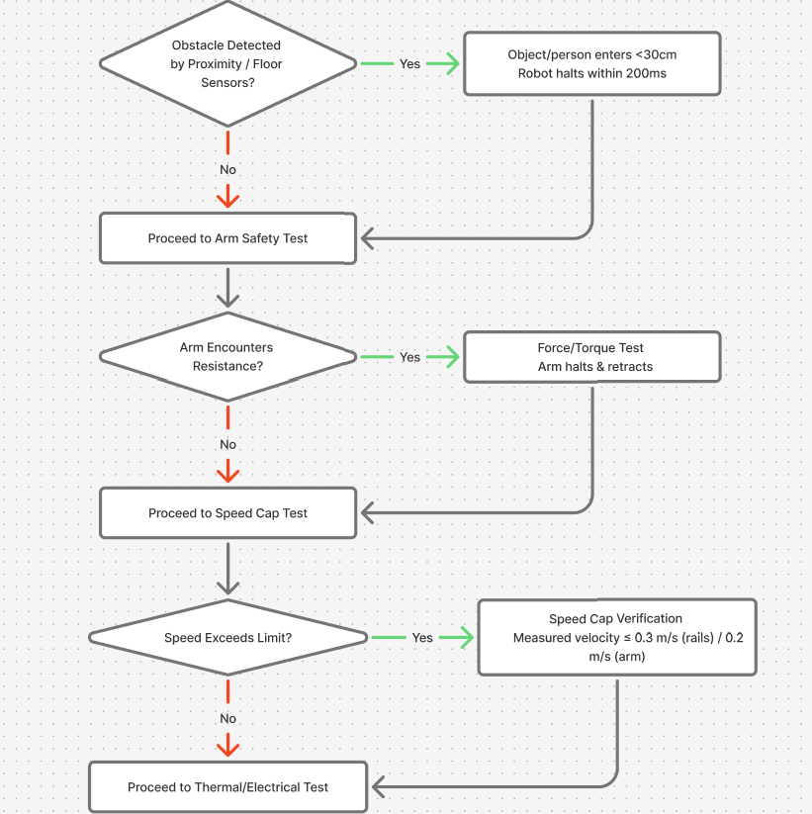
Figure 4.1 - Fallback Decision Flow
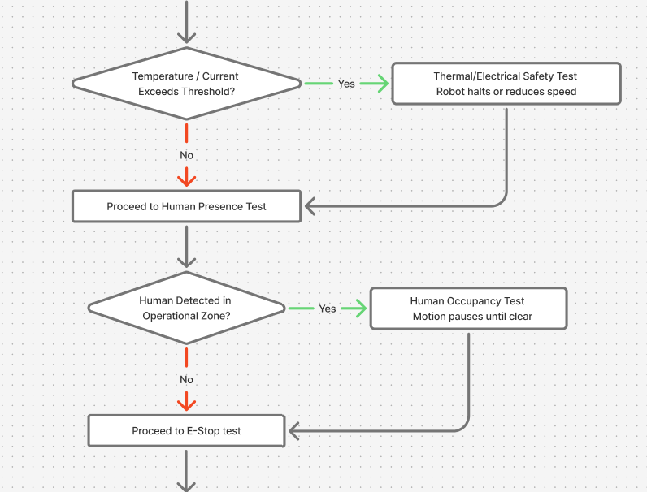
Figure 4.2 - Fallback Decision Flow
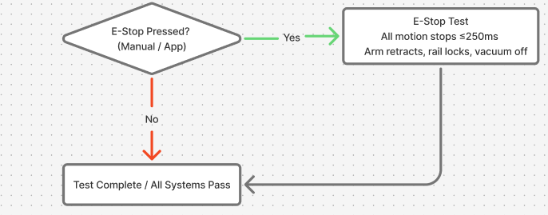
Figure 4.3 - Fallback Decision Flow

Budget / BOM
Allocated Budget: $6,000
Estimated Total Cost: $5,265
An additional allowance of $735 is reserved for unexpected expenses, such as price fluctuations, or last-minute component changes. This ensures the project remains within the allocated budget of $6,000.
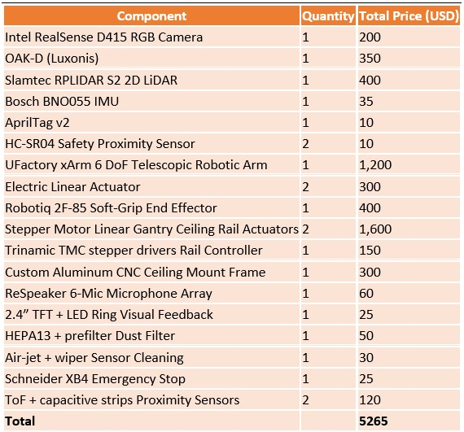

Conclusion
Aerius is an intelligent ceiling-mounted office assistant that combines cutting-edge sensors, cameras, LiDAR, actuators, algorithms ResNet core with extension of YOLOv8, SLAM , and multi-sensor fusion to accomplish exact item handling, real-time mapping, and precise navigation. Strict testing and well-defined success criteria ensured safety, effectiveness, and flexibility. A dependable and scalable system for an independent office organisation is produced by balancing performance, cost, and integration complexity with the chosen hardware and software solutions.

Reference List
A123 Systems. (2023) LiFePO4 Battery Solutions – Specifications and Safety Data. Available at: https://www.a123systems.com / (Accessed on: 16 October 2025).
ABB Robotics (2021) Collaborative safety and force limitation standards. Zurich: ABB Ltd. Available at: https://new.abb.com/products/robotics (Accessed on: 19 October 2025).
Adafruit. (2023) 2.4" TFT Display Modules and RGB LED Rings. Available at: https://www.adafruit.com/ (Accessed on: 16 October 2025).
Adafruit. (2023) Speakers and Audio Modules for Embedded Systems. Available at: https://www.adafruit.com/ (Accessed on: 16 October 2025).
Adafruit. (2025). Adafruit 9-DOF Absolute Orientation IMU Fusion Breakout. Available at: https://www.adafruit.com/product/2472 (Accessed on 14 October 2025).
Anker. (2023) Wireless Charging Solutions and Battery Management. Available at: https://www.anker.com/products/a83b3-anker-prime-charging-docking-station-14-in-1-triple-display-140w?ref=image_product_shelf (Accessed: 16 October 2025).
Bosch Rexroth. (2023) Industrial Aluminum Profiles and Structural Framing Systems. Available at: https://www.boschrexroth.com/ (Accessed on: 16 October 2025).
Bosch Sensortec. (2025). Smart Sensor BNO055. Available at: https://www.bosch-sensortec.com/products/smart-sensor-systems/bno055/ (Accessed on 14 October 2025).
Bosch. (2022) BME680 Environmental Sensor. Available at: https://www.bosch-sensortec.com/products/environmental-sensors/gas-sensors/bme680/ (Accessed on: 16 October 2025).
Bosch. (2023) High-Torque Motors for Continuous Operation. Available at: https://www.bosch.com/ (Accessed on: 16 October 2025).
Boston Dynamics (2021) Safety practices for human-robot collaboration. Waltham, MA: Boston Dynamics, Inc. Available at: https://www.bostondynamics.com/ (Accessed on: 19 October 2025).
Brother International Corporation via StartupNation, 2011. P-touch Means Business survey: disorganization causes 76 working hours lost per employee annually, equating to over USD 177 billion in wasted time. In: StartupNation, “Lost Time Equals Wasted Dollars: Tips for Small Business Workers to Stay Efficient. Available at: https://startupnation.com/grow-your-business/run-your-business-better/lost-time-equals-wasted-dollars-tips-for-small-business-workers-to-stay-efficient/ (Accessed on 09 October 2025).
Circuit Cellar. (2021). Build a Robotic Arm with Linear Actuators. Available at: https://circuitcellar.com/research-design-hub/projects/build-a-robotic-arm-with-linear-actuators/ (Accessed on 14 October 2025).
Cisco. (2023) Managed Power over Ethernet (PoE) Switches – Features and Configuration. Available at: https://www.cisco.com/ (Accessed on: 16 October 2025).
Cooler Master. (2023) Thermal Management Solutions - Heatsinks and Peltier Modules. Available at: https://www.coolermaster.com/ (Accessed on: 16 October 2025).
Dobot. (2025). Dobot Magician - Desktop 4-Axis Robotic Arm, Education Package. Available at: https://profound3d.com/products/dobot-magician-4-axis-robotic-arm-education-package (Accessed on 14 October 2025).
DustTech. (2023) Air-Jet and Wiper Systems for Optical Equipment Maintenance. Available at: https://www.dusttech.com/ (Accessed on: 16 October 2025).
Dyson. (2023) Digital Motor V6 – Product Specifications. Available at: https://www.dyson.com/ (Accessed on: 16 October 2025).
Dyson. (2023) Electrostatic Air Filters and Precipitators. Available at: https://www.dyson.com/ (Accessed on: 16 October 2025).
Firgelli Automations. (2023) Linear Electric Actuators – Product Overview. Available at: https://www.firgelliauto.com/ (Accessed on: 16 October 2025).
Gupta, A., Ramanath, R., Shi, J. And Keerthi, S. S. (2021) ‘Adam vs. SGD: Closing the generalixation gap on image classification’, Proceedings of the OPT2021: 13th Annual Workshop on Optimization for Machine Learning. Available at: https://www.opt-ml.org/papers/2021/paper53.pdf. (Accessed on 24 October 2025)
He, F., Liu, T. and Tao, D. (2020) ‘Why ResNet Works? Residuals Generalize’, IEEE transaction on neural networks and learning systems, 31(12), pp. 5349–5362. Available at: https://doi.org/10.1109/TNNLS.2020.2966319. (Accessed on 20 October 2025)
Hokuyo. (2025). Hokuyo UST-20LX Scanning Laser Rangefinder. Available at: https://www.hokuyo-usa.com/products/lidar-obstacle-detection/ust-20lx (Accessed on 14 October 2025).
Honeywell. (2023) HEPA Air Filters – Product Information. Available at: https://www.honeywell.com/ (Accessed on: 16 October 2025).
Honeywell. (2025). Floor Pressure Sensors. Available at: https://sensing.honeywell.com/floor-pressure-sensors (Accessed on 14 October 2025).
Images.cv (2025). Images.cv. Available at: https://images.cv/ (Accessed on 25 October 2025)
Intel. (2025). Intel NUC Mini PCs. Available at: https://www.intel.com/content/www/us/en/products/boards-kits/nuc.html (Accessed on 14 October 2025).
Intel. (2025). Intel® RealSense™ Depth Camera D415. Available at: https://www.intel.com/content/www/us/en/products/sku/128256/intel-realsense-depth-camera-d415/specifications.html (Accessed on 14 October 2025).
Intel. (2025). Intel® RealSense™ Depth Camera D435. Available at: https://www.intel.com/content/www/us/en/products/sku/128255/intel-realsense-depth-camera-d435/specifications.html (Accessed on 14 October 2025).
International Electrotechnical Commission (IEC) (2016) IEC 60204-1:2016 Safety of machinery- Electrical equipment of machines - Part 1: General requirements. Geneva: IEC. Available at: https://www.iec.ch/ (Accessed on: 19 October 2025).
International Organization for Standardization (ISO) (2011) ISO 10218-2:2011 Robots and robotic devices-Safety requirements for industrial robots-Part 2: Robot systems and integration. Geneva: ISO. Available at: https://www.iso.org/standard/41571.html (Accessed on: 19 October 2025).
International Organization for Standardization (ISO) (2018) ISO/TR 13309:2018 Robots and robotic devices- Guidelines for fail-safe design in robotics. Geneva: ISO. Available at: https://www.iso.org/standard/70829.html (Accessed on: 19 October 2025).
International Organization for Standardization (ISO). (2011) ISO 10218-1:2011 Robots and robotic devices- Safety requirements for industrial robots- Part 1: Robots. Geneva: ISO. Available at: https://www.iso.org/standard/51330.html (Accessed on: 19 October 2025).
International Organization for Standardization (ISO). (2014) ISO 13482:2014 Robots and robotic devices- Safety requirements for personal care robots. Geneva: ISO. Available at: https://www.iso.org/standard/53820.html (Accessed on: 19 October 2025).
International Organization for Standardization (ISO). (2015) ISO 13850:2015 Safety of machinery- Emergency stop function - Principles for design. Geneva: ISO. Available at: https://www.iso.org/standard/52600.html (Accessed on: 19 October 2025).
International Organization for Standardization (ISO). (2016) ISO/TS 15066:2016 Robots and robotic devices- Collaborative robots. Geneva: ISO. Available at: https://www.iso.org/standard/62996.html (Accessed on: 19 October 2025).
InvenSense. (2025). MPU-9250 - InvenSense. Available at: https://invensense.tdk.com/products/motion-tracking/9-axis/mpu-9250/ (Accessed on 14 October 2025).
Knowles. (2023) MEMS Microphones – Product Overview. Available at: https://www.knowles.com/ (Accessed on: 16 October 2025).
KUKA Robotics. (2021) Safety in collaborative robotics: White Paper. Augsburg: KUKA AG. Available at: https://www.kuka.com (Accessed on: 19 October 2025).
Li, Z., Lai, B. and Pan, Y. (2024) ‘Image-Based Composite Learning Robot Visual Servoing With an Uncalibrated Eye-to-Hand Camera’, IEEE/ASME transactions on mechatronics, 29(4), pp. 2499–2509. Available at: https://doi.org/10.1109/TMECH.2023.3341914 (Accessed on 15 October 2025)
Logitech. (2023) Conference and Microphone Array Solutions. Available at: https://www.logitech.com/ (Accessed on: 16 October 2025).
Logitech. (2025). Logitech BRIO Webcam with 4K Ultra HD Video & HDR. Available at: https://www.logitech.com/en-us/products/webcams/brio-4k-hdr-webcam.html (Accessed on 14 October 2025).
Luxonis. (2025). AprilTag vs ArUco markers. Available at: https://robotics.stackexchange.com/questions/19901/apriltag-vs-aruco-markers (Accessed on 14 October 2025).
Luxonis. (2025). Localization and navigation using QR code for mobile robot. Available at: https://www.semanticscholar.org/paper/Localization-and-navigation-using-QR-code-for-robot-Zhang-Zhang/c0aa0b18f55cbb3978e8ee47caad2683e7d4c9ce (Accessed on 14 October 2025).
Luxonis. (2025). OAK-D. Available at: https://shop.luxonis.com/products/oak-d (Accessed on 14 October 2025).
Luxonis. (2025). QR Code Based Navigation. Available at: https://skemman.is/bitstream/1946/41726/1/QR%20Code%20Based%20Navigation.pdf (Accessed on 14 October 2025).
Luxonis. (2025). QR-code based Localization for Indoor Mobile Robot with Artificial Landmark. Available at: https://jrkwon.com/wordpress/wp-content/uploads/2023/02/AIM-2015-Final.pdf (Accessed on 14 October 2025).
Luxonis. (2025). Virtual Experiments on ArUco and AprilTag Systems Comparison for Fiducial Marker Rotation Resistance under Noisy Sensory Data. Available at: https://www.researchgate.net/publication/347020537_Virtual_Experiments_on_ArUco_and_AprilTag_Systems_Comparison_for_Fiducial_Marker_Rotation_Resistance_under_Noisy_Sensory_Data (Accessed on 14 October 2025).
Mabuchi Motor. (2023) RS-775 DC Motor - Product Information. Available at: https://www.mabuchi-motor.com/ (Accessed on: 16 October 2025).
Maker Pro. (2025). Designing and Building Belt-Driven Linear Motion Systems. Available at: https://maker.pro/linear-motion (Accessed on 14 October 2025).
MaxBotix. (2025). Ultrasonic Rangefinder Sensors. Available at: https://www.maxbotix.com/ultrasonic_sensors (Accessed on 14 October 2025).
MeanWell. (2023) Continuous Power Supplies for Industrial Applications. Available at: https://www.meanwell.com/newsInfo.aspx?c=1&i=1456 (Accessed on: 16 October 2025).
Melexis. (2023) MLX90640 Thermal Infrared Sensor – Product Documentation. Available at: https://www.melexis.com/ (Accessed on: 16 October 2025).
Microchip. (2023) Capacitive Touch Sensors - Product Documentation. Available at: https://www.microchip.com/ (Accessed on: 16 October 2025).
Moog. (2023) Slip Rings for Industrial Automation. Available at: https://www.moog.com/ (Accessed on: 16 October 2025).
Hangzhou Grand Technology. (2023) Through-Bore Slip Rings and Flexible Cable Solutions. Available at: https://www.grandslipring.com/ Accessed on: 16 October 2025).
Nano-Clean. (2023) Ultrasonic Dust Removal and Electrostatic Coatings. Available at: https://www.nano-clean.com/ (Accessed on: 16 October 2025).
NASA (2020) NASA safety standards for robotics. Washington, DC: National Aeronautics and Space Administration. Available at: https://www.nasa.gov/ (Accessed on: 19 October 2025).
Netgear. (2023) Unmanaged PoE Switches and Injectors – Product Overview. Available at: https://www.netgear.com/ (Accessed on: 16 October 2025).
Noctua. (2023) PWM Fans and Active Cooling Solutions. Available at: https://noctua.at/ (Accessed on: 16 October 2025).
NVIDIA (2023) Jetson safety application notes: Fail-safe fallback and sensor redundancy strategies. Santa Clara, CA: NVIDIA Corporation. Available at: https://developer.nvidia.com/embedded (Accessed on: 19 October 2025).
NVIDIA. (2023) Jetson Thermal Design and Cooling Recommendations. Available at: https://developer.nvidia.com/embedded/jetson-thermals (Accessed on: 16 October 2025).
NVIDIA. (2025). NVIDIA Jetson Xavier NX Developer Kit. Available at: https://developer.nvidia.com/embedded/jetson-xavier-nx (Accessed on 14 October 2025).
Omron. (2023) A165E Series Emergency Stop Switches - Product Specifications. Available at: https://www.omron.com/ (Accessed on: 16 October 2025).
OnRobot. (2025). RG2 – Flexible 2 Finger Robot Gripper with Wide Stroke. Available at: https://onrobot.com/us/products/rg2-gripper (Accessed on 14 October 2025).
Open Robotics. (2025). ROS 1 Melodic Morenia Documentation. Available at: https://docs.ros.org/en/melodic/index.html (Accessed on 14 October 2025).
Open Robotics. (2025). ROS 2 Documentation. Available at: https://docs.ros.org/en/rolling/index.html (Accessed on 14 October 2025).
Oriental Motor. (2025). Stepper Motor Gantry Systems for Precision Motion. Available at: https://www.orientalmotor.com/products/stepper-motors/gantry-systems.html (Accessed on 14 October 2025).
Panasonic. (2023) Lithium-Ion Batteries for High-Energy Applications. Available at: https://www.panasonic.com/ (Accessed on: 16 October 2025).
Raspberry Pi. (2025). Buy a Raspberry Pi High Quality Camera. Available at: https://www.raspberrypi.com/products/raspberry-pi-high-quality-camera/ (Accessed on 14 October 2025).
Raspberry Pi. (2025). Raspberry Pi 4 Model B. Available at: https://www.raspberrypi.com/products/raspberry-pi-4-model-b/ (Accessed on 14 October 2025).
ReSpeaker. (2023) ReSpeaker Microphone Array – Voice Interface for AI and Robotics. Available at: https://wiki.seeedstudio.com/ReSpeaker_Mic_Array/ (Accessed: 16 October 2025).
Robotiq. (2025). Adaptive Grippers. Available at: https://robotiq.com/products/adaptive-grippers (Accessed on 14 October 2025).
Schneider Electric. (2023) Industrial Emergency Stop Switches. Available at: https://www.se.com/ (Accessed on: 16 October 2025).
Seek Thermal. (2023) Seek Compact Pro – Thermal Imaging Camera. Available at: https://www.thermal.com/ (Accessed on: 16 October 2025).
Sensirion. (2022) SGP30 Indoor Air Quality Sensor. Available at: https://sensirion.com/products/catalog/SGP30/ (Accessed on: 16 October 2025).
Sharp. (2023) Infrared Proximity Sensors - Product Overview. Available at: https://www.sharpsma.com / (Accessed on: 16 October 2025).
Sharp. (2025). Sharp Infrared Sensors. Available at: https://www.sharpsma.com/products/infrared-sensors (Accessed on 14 October 2025).
Siemens (2022) Robotics safety guidelines. Munich: Siemens AG. Available at: https://new.siemens.com (Accessed on: 19 October 2025).
Siemens. (2023) Servo Drives and Motion Control Systems. Available at: https://www.siemens.com/ (Accessed on: 16 October 2025).
SLAMTEC. (2025). RPLIDAR A3. Available at: https://www.slamtec.com/en/Lidar/A3Spec (Accessed on 14 October 2025).
SLAMTEC. (2025). RPLIDAR S2. Available at: https://www.slamtec.com/en/S2/Spec (Accessed on 14 October 2025).
SMC Corporation. (2023) Pneumatic Cylinders – Product Catalogue. Available at: https://www.smc.eu/ (Accessed on: 16 October 2025).
SMC. (2025). Servo Actuators and Linear Motion Solutions. Available at: https://www.smcworld.com/en-us/products/linear-actuators (Accessed on 14 October 2025).
SparkFun. (2023) Distance Sensor Product Documentation. Available at: https://www.sparkfun.com/ (Accessed on: 16 October 2025).
SparkFun. (2023) Mechanical Bump and Limit Switch Sensors. Available at: https://www.sparkfun.com/ (Accessed on: 16 October 2025).
SparkFun. (2023) Piezo Vibration Sensor Product Page. Available at: https://www.sparkfun.com/ (Accessed on: 16 October 2025).
SparkFun. (2023) Piezo Vibration and Sound Sensors. Available at: https://www.sparkfun.com/ (Accessed on: 16 October 2025).
Stereolabs. (2025). ZED Mini Stereo Camera. Available at: https://www.stereolabs.com/store/products/zed-mini (Accessed on 14 October 2025).
STMicroelectronics. (2023) MEMS Accelerometer Product Documentation. Available at: https://www.st.com/ (Accessed on: 16 October 2025).
STMicroelectronics. (2023) Time-of-Flight Sensors for Distance Measurement. Available at: https://www.st.com/ (Accessed on: 16 October 2025).
Subaar, C., Addai, F.T., Addison, E. C. K., Christos, O., Adom, J., Owusu-Mensah, M., Appiah-Agyei, N. and Abbey, S. (2024) Investigating the detection of breast cancer with deep transfer learning using ResNet18 and ResNet34. Biomedical Physics & Engineering Express, vol. 10, no. 3, IOP Publishing Ltd, 18 April. Available at: https://iopscience.iop.org/article/10.1088/2057-1976/ad3cdf/meta (Accessed on 24 October 2025)
Think Robotics. (2025). Designing a 3D Printed Gripper for a Robotic Arm. Available at: https://thinkrobotics.com/blogs/learn/designing-a-3d-printed-gripper-for-a-robotic-arm (Accessed on 14 October 2025).
Trinamic Motion Control. (2023) Stepper Motor Drivers and Motion Control Solutions. Available at: https://www.trinamic.com/ (Accessed on: 16 October 2025).
Trojan Battery. (2023) Lead-Acid Battery Solutions. Available at: https://www.trojanbattery.com/ (Accessed on: 16 October 2025).
UFactory. (2025). xArm 6 DoF Robotic Arm. Available at: https://www.robotshop.com/products/xarm-6-dof-robotic-arm (Accessed on 14 October 2025).
Ultimaker. (2023) 3D Printing Solutions for Prototyping and Manufacturing. Available at: https://www.ultimaker.com/ (Accessed on: 16 October 2025).
Universal Robots. (2020) Human-safe speed regulation in co-working environments. Odense: Universal Robots A/S. Available at: https://www.universal-robots.com (Accessed on: 19 October 2025).
Venkateswara, H. D. (2017). Office-Home Dataset. Available at: https://www.hemanthdv.org/officeHomeDataset.html (Accessed on: 9 October 2025)
Wang, H. et al. (2025) ‘A Survey of the Multi-Sensor Fusion Object Detection Task in Autonomous Driving’, Sensors (Basel, Switzerland), 25(9), p. 2794. Available at: https://doi.org/10.3390/s25092794 (Accessed on 20 October 2025)
Waveshare. (2023) LED Matrix and E-Ink Displays. Available at: https://www.waveshare.com/ (Accessed on: 16 October 2025).
Wu, S., Yan, Y. and Wang, W. (2023) ‘CF-YOLOX: An Autonomous Driving Detection Model for Multi-Scale Object Detection’, Sensors (Basel, Switzerland), 23(8), p. 3794. Available at: https://doi.org/10.3390/s23083794 (Accessed on 20 October 2025)
Zhang, J., Hu, Z. and Wang, X. (2023) ‘Research on Global Path Planning of Robot Based on Ant Colony Algorithm and Gaussian Sampling’, Mathematical problems in engineering. Edited by Y. Zhang, 2023(1). Available at: https://doi.org/10.1155/2023/4194568 (Accessed on 20 October 2025)

Appendix

Contribution Table
Student Name | Student Number | Contribution to Project | Percentage contribution | Signature
Angel Magala | M00971558 | Report section: Software architecture. Video.  Created Read me file.  (GUI of the program) Connected UI to the model. Added evaluation results. | 100% | A.M
Mehtaab Andoo | M00889045 | GUI of the program (webcam,upload,details) Report sections: Introduction, Mission and task, Required skills, Hardware components, Risks and safety, Budget /BOM. Report compilation. Video | 100% | M.A
Sebabatso Maloi | M00919791 | Obtained Datasets, created model, trained and tested model  Report section: Dataset, model plan, and error analysis. Video | 100% | S.M

